Installation notes:

Step 1.
A: For C++.Net, open the project and go to step 2.3;
B: For C#.Net, , J#.Net and VB.Net , create a virtual directory following the following steps:

Step 1.1.
Go to Start -> Settings -> Control Panel -> Administrative Tools -> Internet Services Manager

Step 1.2
In the Internet Services Manager window right-click on the Default Web Site and select New and then Virtual Directory to start the wizard as shown in Figure 1.

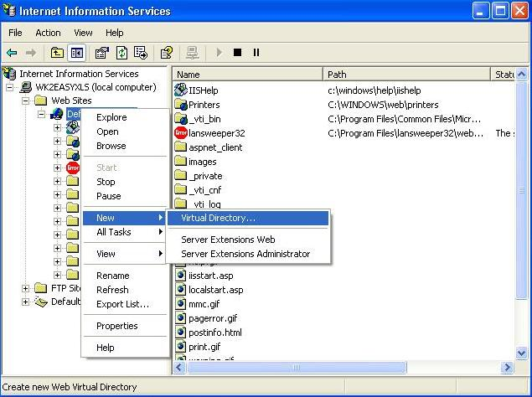

Figure 1

Step 1.3
In the Alias field enter the name of the project: CSharpWebApplication / JSharpWebApplication or VBWebApplication as shown in Figure 2 and click Next.

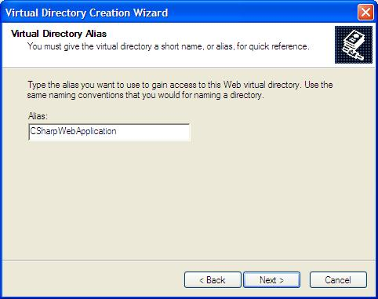

Figure 2

Step 1.4
In the Directory field enter (or browse to) the full path to the directory where the project has been installed ( e.g. C:\Program Files\EU Outsourcing\EasyXLS Trial for .NET v8.0\Dot NET version\Project Tutorials\CSharpWebApplication) and click Next.
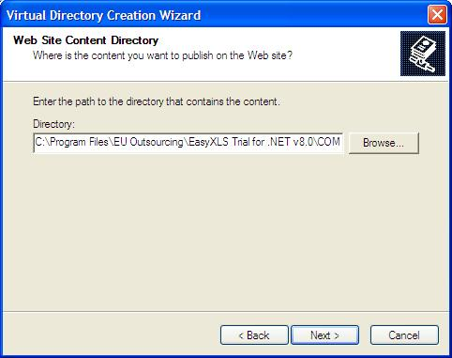

Figure 3

Step 1.5
- In the access permissions panel make sure that the following two items have check-marks next to them:
  - Read
  - Run scripts
and click on Next and Finish buttons.
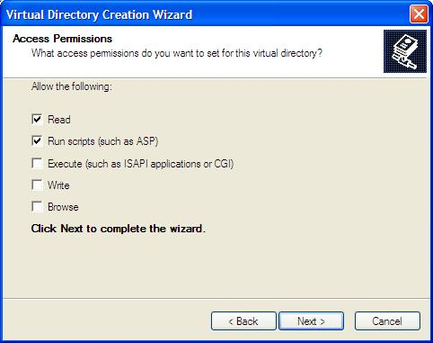
Figure 4

Step 1.6
When you're done you should see the new virtual directory listed under the Default Web Site. Right-click on this new virtual directory and select Properties and you should have the following:

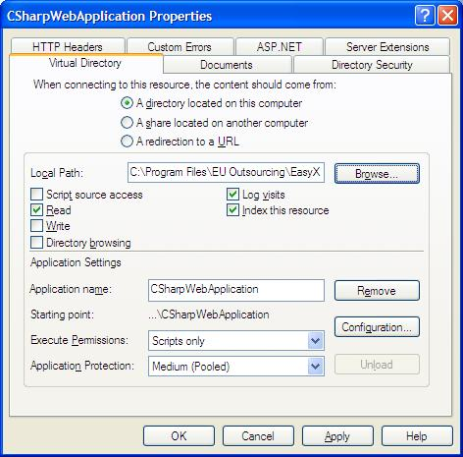

Figure 5

Step2.
Open the project.

Step2.1.
For the C# / J# and VB projects, depending on the location where the EasyXLS library has been installed the following window may appear when the projects are opened using Microsoft Visual Studio. Net

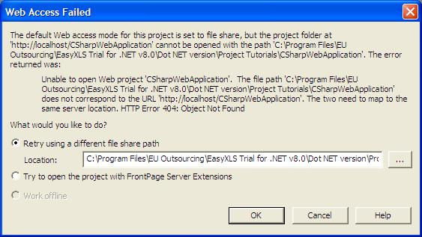
Figure 6

In this case select the Retry using a different file share path option and type or browse the path where the project has been installed and to which the virtual directory created in the first step is pointing to, and click OK.

Step2.2.
Set the project start page as shown in the following picture:
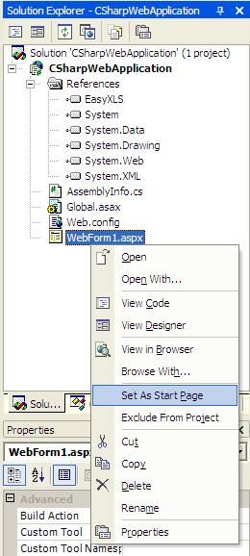

Figure 7

Step 2.3.
Depending on the location where the EasyXLS library has been installed, you might have to update/add the reference to the EasyXLS.dll file.
In order to do this, from the Solution Explorer tab of the Microsoft Visual Studio. Net environment update the reference to the EasyXLS.dll file.

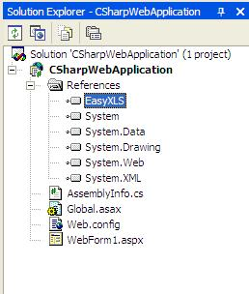

Figure 8

Step2.4
Run the project

